Executive Director’s Board Report, 2nd quarter FY 2024
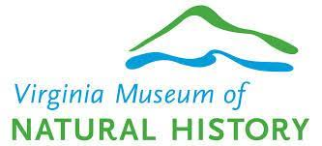
10 February 2024
J. B. Keiper

- VMNH saw success with its Bonz & Booz Halloween Festival in October 2023, with some 2,500 visitors (~38% using Museums for All).
- Admission numbers are up ~5% over last FY, and revenues are up slightly.
- The VMNH-Foundation saw an 18% increase in annual fund donations, and the endowment grew to over $900,00 (12% increase) over the past year.
- Major projects:
  - The Waynesboro EDA made requests for legislative budget adjustments to include moving VMNH-Waynesboro Branch Campus to the construction pool.
  - Progress on the Jean S. Adams Education Pavilion has come slowly, with the contractor still staging equipment at VMNH. The contractor is under obligation via a construction bond.
  - A new major VMNH publication, The Groundwater Isopods of Virginia (VMNH Special Publication #19) has been completed.

Report on Museum Without Walls 2020-2025, and other initiatives of the Virginia Museum of Natural History.

Enhancing our impact as Virginia’s only state institution mandated to investigate, preserve, and exhibit elements of natural history, as well as educate all citizens

- Establish three VMNH Research Centers

OVERVIEW: Develop labs that become research centers where Curatorial Staff collaborate, and work with Education for outreach in multidisciplinary ways.

- The R&C staffing levels are now robust, and they are utilizing the assets of the four new collaborative labs.
- With the future work on Douglas Avenue, needed space for collections growth will be realized.
- Active multidisciplinary labs include:
  - Cultural Heritage Monitoring Lab (with Archaeology)
  - Molecular Systematics Lab (upgrades completed)
    - Invertebrates, Mammals, Amphibians/Reptiles
  - STEM Lab (3D printing, macrophotography, specialized computers)
  - Microscopy and Student Training Lab (IMLS-funded)
    - Well used by education, Master Naturalists, et alia.
    - Asset to R&C

- Rehab the Douglas Avenue building to support collections growth

OVERVIEW: The original museum building will receive a new roof and upgrades to electric, plumbing, and HVAC through Maintenance Reserve funds. The internal environment will be suitable for long-term storage needs of the curatorial staff.

- VMNH has received approval to hire a A&E firm under a term contract who will do all the work and bid the remaining improvements as one project. This will include building envelope, HVAC, plumbing, and electric. This will increase project efficiency.

- Obtain reaccreditation from the American Alliance of Museums

OVERVIEW: VMNH is due to apply for reaccreditation with AAM, which is the gold standard for best practices in collections care, service, and financial responsibility in 2025.

- An ad hoc Reaccreditation Committee has been formed.
  - First Committee meeting (planning) held in October, 2023.
- Meetings to coordinate work on the reaccreditation process will begin early in the new FY.
- The reaccreditation materials are due November 2024.

Sustaining VMNH by enhancing draw and impact through expanded facilities that will impart high quality scientific information and nature-based experiences for all

- Create an early childhood activity and learning center

OVERVIEW: The Library space is an underutilized facility at VMNH, and with upgrades to Douglas Avenue it will be suitable for long-term storage of the library materials. An exhibit and activity space will be created that focuses on pre-K through 5th grade to support our youngest visitors.

- Staff are preparing to once again ask for funds to support the conversation of the Library space during the 2024 General Assembly session.
- Staff are prepping the space to become a new exhibit area.
- Interest in purchasing of the compacting shelves is high.

- Build the Jean S. Adams Education Pavilion

OVERVIEW: A pavilion will be established behind the museum to connect visitors to the nearby J. Frank Wilson Park, and will support durable outdoor exhibits featuring lessons in forest ecology.

- The contractor has slowly staged construction assets at VMNH. This should speed up as the company completes another nearby project. The firm us under a construction bond, which will help protect VMNH from any long-term delays.

- Explore the Treetop Canopy Walk concept

OVERVIEW: The concept of connecting the future Jean S. Adams Education Pavilion to J. Frank Wilson Park via a treetop canopy trail is being explored.

- Staff and trustees have communicated with two separate architects to learn about the process and challenges of building a Canopy Walkway.
- Any significant steps in planning and preparation will await completion of the Jean S. Adams Education Pavilion.

- Establish the first permanent branch campus of VMNH near the confluence of the Blue Ridge Parkway, Skyline Drive, and the Appalachian Trail

OVERVIEW: A Feasibility Study, Master Plan, and Capital Campaign Plan were all completed in 2015 to explore the concept of building a dedicated museum building next to Constitution Park in Waynesboro, VA. The City has committed $1 million in support of the project. This branch campus will draw from Shenandoah National Park and surrounding cities, giving VMNH access to new audiences and new revenue sources.

- A draft 100% Schematic Design document has been compiled. Approval from DEB is sought
- Ongoing discussions about exhibit content are ongoing in advance of Preliminaries. University, government, and other partners have been engaged in developing a compendium of exhibit topics relevant to the campus’ galleries. A fish working group, with a focus on trout biology, will be initiated in support of potential exhibit content.
- Legislation initiated by Delegate Ellen Campbell and Senator Christopher Head requests both General Fund support and support via a VPBA bond issuance to provide capital funding in the next biennium.
- The VMNH Science Outreach Experience Trailer was opened via a Chamber of Commerce Ribbon Cutting on December 9th, 2023. About 80 people were in attendance.
  - Phase I exhibits were added.
  - Further exhibits will be installed prior to the 27 April 2024 Waynesboro Riverfest.
  - While basic maintenance has stabilized the trailer, more will need to be done.

Other Highlights

- The Groundwater Isopods of Virginia (Isopoda: Asellidae and Cirolanidae), VMNH Special Publication #19, has been released:
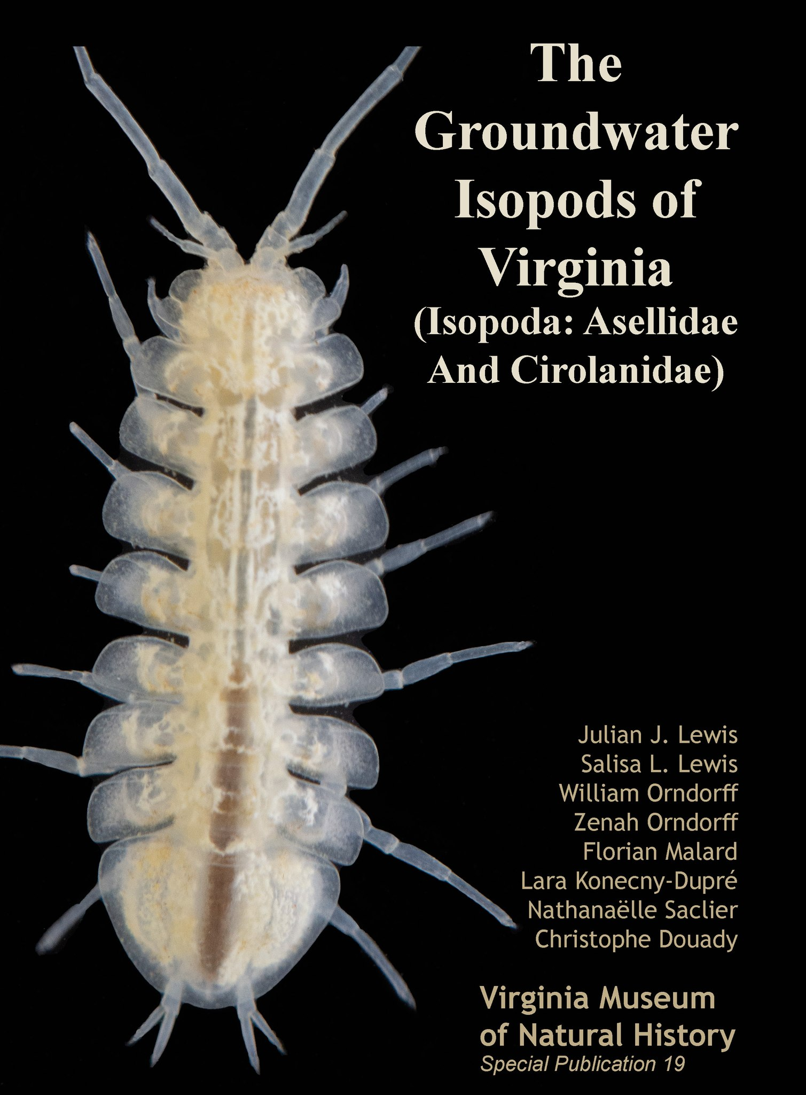

- The VMNH festival program is on track to match last year’s numbers in attendance and revenues. Lat quarter’s Bonz & Booz Halloween Festival saw some 2,500 visitors, with about 950 using the Museums for All program for free admission. Numbers of visitors using their EBT card for free admission stands at an average of 18.3% of visitors per quarter this FY, vs. 17.6% per quarter last FY.

- VMNH-Foundation Endowment

    - The endowment currently its at slightly over $900,000.
    - The VMNH-Foundation will vote on a recommendation to keep the management of the fun as is, and reconsider options in financial management when a value of $5 million is reached.
    - Recent contributions to the endowment:
      - A number of monthly recurring gifts through the Discovery Champions option.
      - A $15,000 gift in support of the Pete Henika Memorial Fund.

- The energy savings project has shown positive results in the July – November 2023 time period. During that time:

    - Compared to the same period in 2022, a savings of 179400 kW occurred.
    - At $0.11/kWH, this produced nearly $20,000 in savings.
    - The LED lighting (44%) and HVAC recommissioning (29%) are the two largest areas of energy savings.
    - The solar array produced 12% of our electric needs during this period.

- Legislative Informational Day
    - 7 February 2024
    - General Assembly Building
    - Leave behinds

- Speakeasy on Starling

    - 2 March 2024, 630-930pm
    - Food, beverages, activities, social time
    - 200 tickets to be sold
    - Interactive way to say ‘thank you’ to community
      - Silent Auction
      - Velociraptor egg hunt
      - Curator and Educator Stations
      - Special tasting
      - Photo booth
      - Catered food, beer/wine, cocktail station
      - Speakeasy theme with special experience that is password protected
    - Revenues
      - Tickets $30
      - Beer/wine $5 (2 tickets included)
      - Silent auction

