Virginia Museum of Natural History
Policies for Live Animals

11 August 2023 draft for Research & Collections Committee Vote

Table of Contents
I. Preface 2
II. Institutional Commitment and Animal Care 2
III. Acquisition 2
IV. Access and Use of Collections 3
V. Removal and Disposal of Deceased Animals 3
VI. Administration and Employee Responsibilities 3
VII. Permits, Inventory, and Annual Assessment of Resources 4
VIII. Transparency and Accountability 4
APPENDIX I. Live Animal Acquisition Consideration Form 5
APPENDIX II. Gift-In-Kind Form 8
APPENDIX III. Live Animal Annual Assessment Form 9
APPENDIX IV. Guidelines for Care and Maintenance 11

I. Preface

The Virginia Museum of Natural History (VMNH) uses live invertebrates, fish, amphibians, and reptiles in exhibits, education, and public programs as part of its mission to interpret Virginia’s natural heritage within a global context in ways that are relevant to all citizens of the Commonwealth. These living collections serve an important role by helping to instill a sense of understanding and respect for creatures that are often misunderstood for a variety of reasons. The VMNH will not keep live mammals or birds without undergoing the American Zoological Association’s accreditation process.

II. Institutional Commitment and Animal Care

The VMNH is committed to providing the financial, physical, and human resources necessary to safely and humanely care for the animals entrusted to its care. The Manager of the Department of Education and Public Programs (DEPP) and the Exhibits Manager, in consultation with other relevant staff and outside animal-care experts, are responsible for recommending to the VMNH Executive Director all the resources needed to effectively care for the VMNH’s live animals that are housed on exhibit. Research and Collections Division staff are responsible for effective care of all live animals housed in their research laboratories and office spaces.

The VMNH staff research the best practices of care and maintenance for each type of animal, and then apply these practices to the fullest extent possible. Under no circumstances will the VMNH take on responsibilities for numbers or types of animals that are beyond its ability to care for humanely, nor will it engage in any activity that threatens the welfare of animals, staff, or visitors. All staff assigned to assist in the maintenance of VMNH animals receive detailed training in the care and handling procedures for each species. The live animal collection at the VMNH is under the care of a licensed veterinarian, as required by permits issued by state and federal regulatory agencies. Yearly wellness checks will be conducted, and veterinary medical staff are contacted if emergency care is needed.

The live animal collection is funded in a variety of ways, such as through grants and individual donations. Funds acquired for the live animal collection may be secured through the Virginia Museum of Natural History Foundation, a 501(c) 3 non-profit organization that exists to support the mission and programs of the VMNH.

III. Acquisition

Acquisition of live animals is in full compliance with all applicable laws and regulations of local, state, federal, and international authorities. Animal ambassadors that are used in education and public programs are generally acquired through proposed donations that are considered on a case-by-case basis.
Acquisition of live animals requires VMNH staff to consider multiple criteria, including: the animal’s health, habitat needs, veterinary care requirements, cost of care, legal concerns, and available staff resources. These criteria are detailed in the Live Animal Acquisition (LAA)-Consideration Form (Appendix I).
When an opportunity to acquire an animal arises an LAA-Consideration Form is completed by the Manager of DEPP, Exhibits Manager, or a Research Curator who ultimately will be responsible for the animal’s care. After completion of the LAA-Consideration Form, that staff member will consult with other staff, as needed, and make a recommendation of whether or not to acquire the animal.
If recommended that the VMNH should acquire the animal, the VMNH Executive Director is asked to review and sign the LAA-Consideration form. If the Executive Director approves the acquisition, the staff member ultimately responsible for the animal’s care, will, if applicable, ask the potential donor to complete a Gift-In-Kind form (Appendix II). Copies of all of these forms are provided to the VMNH Registrar.
Upon arrival at the VMNH, all live animals are placed in an appropriate enclosure and quarantined for an appropriate length of time, as determined after consultation with a licensed veterinarian and reviewing pertinent live-animal care procedures.

IV. Access and Use of Collections

The VMNH living collections are not available for loan. Animals used in exhibits are housed on display. Animals used in public programs are either housed in the Suzanne M. Lacy Education Center, or they are housed in research laboratories and office spaces that are not accessible to the public.

V. Removal and Disposal of Deceased Animals

Live animals are not accessioned (or deaccessioned) by the VMNH. Deceased animals are removed from their enclosure and frozen as soon as possible after death. They are then considered by a Research Curator or the Manager of DEPP for acquisition as VMNH specimens, subject to the review process outlined in the VMNH Collections Policies. VMNH staff will properly dispose of remains not under consideration for acquisition.

VI. Administration and Employee Responsibilities

The live animals housed in exhibits and the Suzanne M. Lacy Education Center are under the day-to-day care of the DEPP. Animals housed in research laboratories and office spaces are under the daily care of the Research and Collections division staff. All staff follow a chain-of-care in the case of unplanned absences. Outside of DEPP, the Exhibits Manager, and the Biology Research Technician are equipped to care for the collections on display in the absence of DEPP staff. Animals housed in research laboratories and office spaces are cared for by curators, staff scientists, and research technicians. All staff responsible for animal care are trained in proper methods for care, feeding and watering, habitat maintenance, and emergency procedures. Staff are also trained on species-specific information to share with the general public during programming.
In the event staff determines that resources are no longer available to appropriately care for a live animal, the VMNH will make every attempt to rehome it with a suitable organization.

VII. Permits, Inventory, and Annual Assessment of Resources

The state of Virginia requires a permit, issued by the Department of Wildlife Resources, to exhibit wild animals. This permit requires the signature of a certified veterinarian, as well as annual wellness checks. Permit applications are submitted annually, with updated inventories of all live animals housed at the VMNH. As part of this process, the VMNH will annually assesses the financial, physical, and human resources necessary to care for each live animal, using the Live Animal Annual Assessment Form (Appendix III).
It is the responsibility of the Manager of DEPP to maintain current state permits and update inventories as needed. The Manager of DEPP is responsible for providing a copy of all state permits to the VMNH Registrar.

A federal permit, issued by the U.S. Department of Agriculture’s Animal and Plant Health Inspection Service, is required for the VMNH to display its colony of leaf-cutter ants. It is the responsibility of the VMNH Registrar to maintain current federal permits.

VIII. Transparency and Accountability

The VMNH manages its collection of live animals in the public trust. The VMNH Policies for Live Animals, and all other documents related to live animals housed at the VMNH (e.g., Guidelines for Care and Maintenance, Appendix IV) are available for public review.

The Virginia Freedom of Information Act (FOIA), located in § 2.2-3700 et seq. of the Code of Virginia, guarantees citizens of the Commonwealth and representatives of the media access to public records held by public bodies, public officials, and public employees. Citizens have the right to request and/or receive copies of public records, and to request that any charges for the requested records be estimated in advance. The VMNH is legally obligated to comply with all FOIA requests, if the request is for existing documents and the records are identified with “reasonable specificity.”

APPENDIX I. Live Animal Acquisition Consideration Form - Page 1 of 3

LIVE ANIMAL ACQUISITION - CONSIDERATION FORM

Date:

Name of Source (Seller or Person/Institution Making Offer to Donate)

Email Address:

Phone Number(s):

Has the animal(s) been seen in person by VMNH Staff? Yes No
Has the animal(s) been formally offered to the VMNH? Yes No
Or, is this a pre-offer review? Yes No

TYPE OF ANIMAL(S):

Invertebrate
Arthropod (insects, arachnids, crustaceans, myriapods)
Mollusk (chitons, snails, bivalves, squids, octopuses)
Annelid (earthworms, leeches)
Cnidarians (hydras, jellyfishes, sea anemones, corals)

Amphibian
Reptile
Fish (circle one): freshwater saltwater

PRICE, QUANTITY, AND PHYSICAL CONDITION: (Be as accurate as possible.)
Sales price (if applicable) and quantity of each type of animal being offered, include size of the animal:

HABITAT:
Are there any supplies being donated or sold with the animal? YES NO
If yes, please describe and provide sales price, if applicable:

Is there any equipment being donated or sold with the animal? YES NO
If yes please describe and provide sales price, if applicable:
Page 1 of 3
21 Starling Avenue, Martinsville, VA 24112, T. 276 634 4141 F. 276 634 4199 E. information@vmnh.virginia.gov W. www.vmnh.net

APPENDIX I. Live Animal Acquisition Consideration Form - Page 2 of 3

HEALTH:
Does the animal show signs of illness? YES NO SOME:
When was the last time it was seen by a vet?
How old is the animal?

Are quarantine facilities available? YES NO

LEGALITIES:
Does the source (owner) have all necessary permits and any other paperwork (e.g. sales documentation) for each animal? YES NO SOME:
If not, how was it acquired?
When was the animal acquired?
Are there any legal restrictions to consider (i.e., endangered, threatened)? (list all concerns):

FUTURE NEEDS:

SUPPLIES AND EQUIPMENT:
1. Are there any supplies that will need to be purchased? YES NO
If yes, please describe and include estimated cost:

2. Is there any equipment that will need to be purchased? YES NO
If yes please describe and include estimated cost:

CARE: What food will the animal need?

VET SERVICES: Describe anticipated veterinary care needs:

STAFF RESOURCES: Estimate how much time for care is needed weekly?

What is the projected annual cost of food and supply needs?
Supplies/Equipment:
Food:
Vet Services:
Total Annual Cost Projected:

Page 2 of 3
21 Starling Avenue, Martinsville, VA 24112, T. 276 634 4141 F. 276 634 4199 E. information@vmnh.virginia.gov W. www.vmnh.net
APPENDIX I. Live Animal Acquisition Consideration Form - Page 3 of 3

What is the projected annual staff time needed to provide proper care?

POTENTIAL DISPLAY, EDUCATIONAL, AND PROGRAMMING USE:
List any benefit having this animal will provide to enhance educational and programming at the VMNH:

GENERAL COMMENTS ON ACQUISITION: (Pros and Cons)

ACCEPTANCE OR DENIAL by the VMNH staff member responsible for the care of animal(s) noted on this form (e.g., DEPP Manager, Exhibits Manager, Research Staff).

RECOMMEND TO ACCEPT: YES NO

VMNH Staff: Date:
Signature

Printed Name and Title

EXECUTIVE DIRECTOR ACCEPTS: YES NO

Executive Director: Date:
Printed Name and Signature

Potential Donor/Seller offering the animal notified of decision:
YES Date Notified:

If animal is accepted, please complete a Gift in Kind form and provide copies of all documentation to the museum registrar.

Page 3 of 3
21 Starling Avenue, Martinsville, VA 24112, T. 276 634 4141 F. 276 634 4199 E. information@vmnh.virginia.gov W. www.vmnh.net

APPENDIX II. Gift-In-Kind Form

GIFT-IN-KIND FORM

Date(s) Item(s) Donated:

Item(s) Received From (Donor’s Name):
Donor’s Address:

Donor’s Phone #:

Donor’s Tax Identification Number: (Only if value claimed for tax deduction purposes.)

Item(s) for (VMNH Recipient): Department:
(Printed name and Title)

Quantity and Type/Description of Item(s) [e.g., supplies, equipment, specimens(s)]:
Note that “specimen(s)” includes donated live animal(s) and the progeny of said specimen(s).

Total Value* of Donated Item(s): $

Means of Valuing (e.g., fair market value):

* In accordance with the Tax Reform Act of 1984, it is the responsibility of the Donor to obtain any appraisals necessary for donated property claimed as charitable deductions.

By signing this document, the Donor indicates they have the right to transfer said item(s), such item(s) being free and clear of all encumbrances. The Donor transfers the item(s) noted on this document, which shall constitute an irrevocable and unconditional gift of same by the Donor to The Virginia Museum of Natural History, including all rights, title, and interest in and to the above item(s) absolutely and forever.

Signature of Donor: Date:

Signature of VMNH Recipient: Date:
Signature and Printed Name/Title

Original form should be given to the museum registrar for the museum’s permanent files.

21 Starling Avenue, Martinsville, VA 24112, T. 276 634 4141 F. 276 634 4199 E. information@vmnh.virginia.gov W. www.vmnh.net

APPENDIX III. Live Animal Annual Assessment Form (Front of Form)

LIVE ANIMAL ANNUAL ASSESSMENT FORM

Date:

TYPE OF ANIMAL(S):

Invertebrate
Arthropod (insects, arachnids, crustaceans, myriapods)
Mollusk (chitons, snails, bivalves, squids, octopuses)
Annelid (earthworms, leeches)
Cnidarians (hydras, jellyfishes, sea anemones, corals)
Amphibian
Reptile
Fish (circle one): freshwater saltwater

QUANTITY AND PHYSICAL CONDITION: (Be as accurate as possible.)
Quantity and size of the animal(s):

HEALTH:
Does the animal show signs of illness? YES NO SOME:
When was the last time it was seen by a vet?
How old is the animal?
How long has the animal been at VMNH:

Other comments/considerations:

NEEDS WITHIN THE NEXT YEAR:

SUPPLIES AND EQUIPMENT:
1. Are there any supplies that will need to be purchased? YES NO
If yes, please describe and include estimated cost:

2. Is there any equipment that will need to be purchased? YES NO
If yes, please describe and include estimated cost:

21 Starling Avenue, Martinsville, VA 24112, T. 276 634 4141 F. 276 634 4199 E. information@vmnh.virginia.gov W. www.vmnh.net
APPENDIX III. Live Animal Annual Assessment Form (Back of Form)

NEEDS - CONTINUED:

CARE: What food will the animal need and what is the estimated cost?

VET SERVICES: Describe anticipated veterinary care needs:

STAFF RESOURCES: Estimate how much time for care is needed weekly:

What is the projected total cost of vet care, food, and supplies over the next year?

What is the projected total amount of staff time necessary over the next year?

Other comments/considerations:

POTENTIAL DISPLAY, EDUCATIONAL, AND PROGRAMMING USE:
List any benefits this animal provides to enhance educational and/or programming at VMNH:

GENERAL COMMENTS ON RETAINING THIS ANIMAL AT THE VMNH: (Pros and Cons)

ANNUAL ASSESSMENT COMPLETED by the VMNH staff member responsible for the care of animal(s) noted on this form (e.g., DEPP Manager, Exhibits Manager, Research Staff).

RECOMMEND TO RETAIN: YES NO

VMNH STAFF: Date:
Signature

Printed Name and Title

EXECUTIVE DIRECTOR ACCEPTS: YES NO

Executive Director: Date:
Printed Name and Signature
Please provide copies of all permits to the VMNH registrar.

APPENDIX IV. Guidelines for Care and Maintenance – page 1 of 19

Guidelines for Use of Live Amphibians and Reptiles in Field and Laboratory Research, Second Edition. 2004. Revised by the Herpetological Animal Care and Use Committee (HACC) of the American Society of Ichthyologists and Herpetologists.
https://static1.squarespace.com/static/618bf11a71fcdf5398996eda/t/618fbed9a68bdd5cbcc95f78/1636810457669/guidelines_herps_research_2004.pdf

Guidelines for Use of Fishes in Research. 2013. UFR (Use of Fishes in Research) Committee, American Fisheries Society, Bethesda, Maryland. https://static1.squarespace.com/static/618bf11a71fcdf5398996eda/t/618fbed1f40e6c713dfa71ee/1636810449675/asf-guidelines-use-of-fishes-in-research-2013.pdf

Guidelines for Care of Invertebrates, as provided on 2 January 2023 by staff of the Cincinnati Zoo and Botanical Garden (see following pages).

APPENDIX IV. Guidelines for Care and Maintenance – page 2 of 19

Baja Whip-spider (Acanthophrynus coronatus)
Animal Husbandry SOP, World of the Insect, Cincinnati Zoo & Botanical Garden
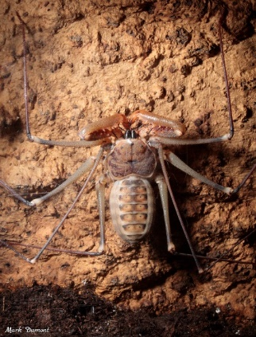
Very little is known about this species. It is unknown at this time how to tell males from females, so to ensure the safety of each animal, they are housed separately. These animals were housed together when we received them, but aggression and cannibalism was observed, so they were separated.

General Care: Mist daily. Two adult crickets are added every week. This animal may also be hand-fed with forceps. Never add more than 2 crickets at a time. This prevents crickets breeding in the exhibit display as well as avoids injury to the whip-spider if it molts. Glass is cleaned daily with a wet paper towel.

Other Care: Since the exhibit display is set up with live plants, this exhibit gets stripped out as needed. While on display, trim plants as needed and make sure they are watered once a week. Individuals in the keeper area should receive the same care. This species should never be handled to ensure low stress levels. If you would like to show them to zoo guests for private tours, please keep them on the cork-bark and never touch them.

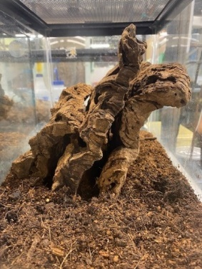
Moving or transferring a live tarantula: Move them on the cork-bark they use for hiding. Do not touch them in the process as this will frighten them and encourage them to run. This is a non-venomous, docile species, but extremely fast when disturbed. Simply move them to an empty tank if their “home” tank needs to be cleaned. A mixture of coconut fiber and potting soil can be used for the substrate. Always provide 3 pieces of cork bark, so they can hide. Soil should be at least 2 inches deep to ensure a semi-moist and humid environment.
Example of cork pieces for hiding areas.
Bark should always be vertical and close together.

APPENDIX IV. Guidelines for Care and Maintenance – page 3 of 19

Desert Rainworm (Orthoporus ornatus)
Animal Husbandry SOP, World of the Insect, Cincinnati Zoo & Botanical Garden
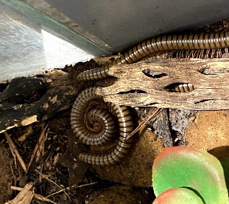
Daily Care: Mist substrate in the morning and top off the water dish in the keeper area habitat as needed. Wipe and clean the glass with RO water.

- Sunday: Remove the old banana, cucumber, and sweet potato from both the public area habitat and the keeper area habitat. The public area habitat should get one – ¼ of a banana with tetramin sprinkled on top, one slice of sweet potato, and one slice of cucumber. The keeper area habitat should get one – ½ slice of banana with tetramin sprinkled on top, two chunks of sweet potato, two slices of cucumber, and a piece of romaine. Cat food should be added as needed to the dish in the keeper area. Please sprinkle powdered shrimp chitin on top of all the food.
- Monday:
- Tuesday: Remove the old banana, cucumber, and sweet potato from both the public area habitat and the keeper area habitat. The public area habitat should get one – ¼ of a banana with tetramin sprinkled on top, one slice of sweet potato, and one slice of cucumber. The keeper area habitat should get two – ½ slice of banana with tetramin sprinkled on top, two chunks of sweet potato, two slices of cucumber, and a piece of romaine. Cat food should be added as needed to the dish in the keeper area. Please sprinkle powdered shrimp chitin on top of all the food.
- Wednesday:
- Thursday: Remove the old banana, cucumber, and sweet potato from both the public area habitat and the keeper area habitat. The public area habitat should get one – ¼ of a banana with tetramin sprinkled on top, one slice of sweet potato, and one slice of cucumber. The keeper area habitat should get two – ½ slice of banana with tetramin sprinkled on top, two chunks of sweet potato, two slices of cucumber, and a piece of romaine. Cat food should be added as needed to the dish in the keeper area. Please sprinkle powdered shrimp chitin on top of all the food.
- Friday:
- Saturday:

Quarterly Care: The public area habitat should be stripped and cleaned quarterly. Remove any adults and subadults that may be on the props or in the leaf mold and place them in a critter keeper. Remove and wash the props with soap and water and rinse them thoroughly. Pour the old leaf mold* into a 4-gallon, square bucket which will be dated with masking tape, three days from the current date. This bucket will be placed in the freezer for the next 72 hours at -20 degrees Fahrenheit. The exhibit
APPENDIX IV. Guidelines for Care and Maintenance – page 4 of 19

Desert Rainworm (Orthoporus ornatus) – Continued
Animal Husbandry SOP, World of the Insect, Cincinnati Zoo & Botanical Garden

should be cleaned with soap and water and dried off with paper towels. About 1” of mostly leaf mold* mixed with a little sand, and coconut fiber (to give it a more natural look) should be placed in the habitat following all props and animals.

Yearly Care: About once or twice a year completely strip the keeper area habitat. Place the millipedes into a separate enclosure with paper towels and collect any substrate that has hatchlings or eggs. All excess leaf mold can be placed in a 4-gallon, square bucket which will be dated with masking tape, three days from the current date. This bucket will be placed in the freezer for the next 72 hours at -20 degrees Fahrenheit. The cork bark should be scrubbed and rinsed with water. Dry the rearing enclosure with paper towels. Fill a 10 gallon tank completely with leaf mold* except for the top 3”. The soil containing the hatchlings and eggs should be placed about 2” under the surface of leaf mold. Place cork bark on the surface of the substrate along with one – ½ slice of banana with tetramin sprinkled on top, two chunks of sweet potato, two slices of cucumber, one piece of romaine lettuce, a small dish with dry cat food, and a shallow water dish with gravel in it. Please sprinkle powdered shrimp chitin on top of all the food. Throughout the year, leaf mold can be added to the surface of the enclosure as needed. As this is the breeding tank, there should always be a hide as well as some fresh leaf mold. The millipedes tend to break it down quickly so keep an eye on the substrate levels.

*Leaf mold: All leaf mold used for husbandry has been collected from the outdoor leaf mold pile (which horticulture collects from zoo grounds) and placed in a large vacuum-sealed bag for 5 days. When the leaf mold is added to the bags, all sticks are removed by hand first in order to keep the bag intact when the air is vacuumed out. Currently the bags are being stored in the room that excess the fire stick display in the back vestibule. The air is vacuumed out of the bags at least twice during the 5 day period. This allows the leaf mold to keep its nutritional value as well as rid it of all potential pests/predatory species.
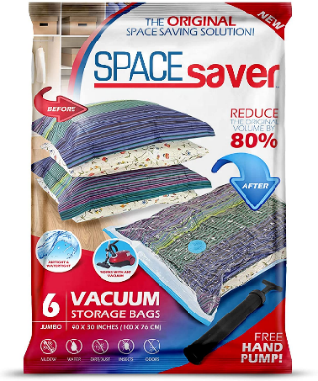

APPENDIX IV. Guidelines for Care and Maintenance – page 5 of 19

Emperor Scorpion (Pandinus imperator)
Animal Husbandry SOP, World of the Insect, Cincinnati Zoo & Botanical Garden

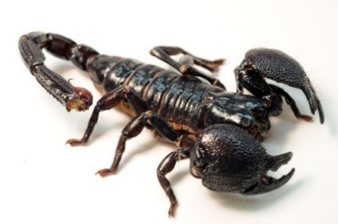

Daily Care: Dead or eaten crickets should be removed from the exhibit daily with forceps. Adult crickets are added (amount depends on population and if live crickets remain from the previous day). Glass is cleaned daily with a wet paper towel. Mist entire tank and fill water dish. Clean the piece of glass that is used for the hiding spot. All white scorpion waste should be removed daily. Clean out water dish with soap and hot water. Rinse thoroughly. Change gravel if needed.

Monthly Care: Completely strip all enclosures. Scorpions can be removed and placed in a 10-gallon tank while cleaning their exhibit enclosure. Clean all plastic plants with hot water and soap. Replace them as needed. Refill exhibit display with two full scoops of coconut fiber or organic soil. Also add leaf litter for hiding places.

YOUNG SCORPIONS (see photo below)

If a female has young on her back, carefully separate her (and the young) from other adults into her own small enclosure. Make sure she has a low water dish and something to hide under. The hide should be tall enough for the female to walk into without disturbing the young. Plastic tubes cut in half in the clean room cabinet work well for this. Once she has entered the hide-a-away tube, DO NOT DISTURB HER OR THE YOUNG AGAIN. It will be tempting to check on them, but total privacy is needed for the young to develop and to also keep down aggression from the female (mother). Stress on the female may cause cannibalism on the young. The end of the plastic tube can be pushed up against the glass of the tank, so they will be visible inside by using a flashlight.

When feeding her, crush the head of a live adult cricket and hold it up to her claws until she takes it. Feeding the young is not yet necessary, as they will remain on her back for at least two weeks before they complete their first molt. Once the young have left her back and have molted (they will slowly darken in color), place the female back in with the other adult scorpions where she came from originally. Young can remain together in the small, separate tank until they are large enough to be combined with other collection scorpions. Now the young can be fed live pinhead crickets twice a week or as needed. NOTE: We sometimes leave the adult female with the young for up to two months just to be cautious. Emperor scorpions are great mothers! Leaving them with their young is not a concern, if the female is well fed.

APPENDIX IV. Guidelines for Care and Maintenance – page 6 of 19

Emperor Scorpion (Pandinus imperator) - Continued
Animal Husbandry SOP, World of the Insect, Cincinnati Zoo & Botanical Garden

Venomous Species Special Instructions: While this species has a mild venom, is not considered an aggressive animal. Handling them is acceptable. Use more caution with young scorpions, as they tend to be a little more aggressive. Baby scorpions are unable to sting, since their stinger cannot penetrate your skin. Use extreme care handling them, as they fall off your hand easily.

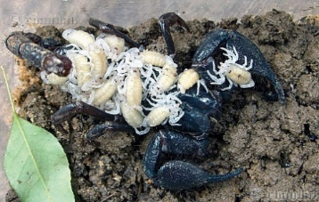
Scorplings/young with female

APPENDIX IV. Guidelines for Care and Maintenance – page 7 of 19

Giant African Millipede (Archispirostreptus gigas)
Animal Husbandry SOP, World of the Insect, Cincinnati Zoo & Botanical Garden

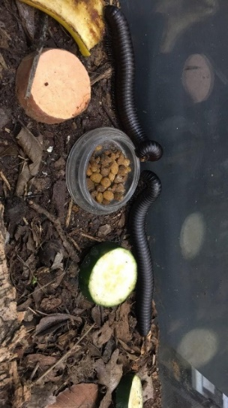

Temperature & Humidity: Temperature: 75°F – 78°F Humidity: 80% - 90%
Daily Care: Mist substrate in the morning and top off dry cat food and water dish as needed. Wipe and clean the glass with RO water.

- Sunday: Remove the old bananas, cucumbers, and sweet potatoes from the exhibit. Replace them with one – ¼ slice of banana with tetramin sprinkled on top, one slice of sweet potato, and one slice of cucumber. Top off the cat food as needed. Please sprinkle powdered shrimp chitin on top of all the food. The keeper area should receive two - ¼ slices of banana with tetramin sprinkled on top, two slices of sweet potato, two slices of cucumber, as well as 2-4 pieces of romaine lettuce underneath their cork bark.
- Monday:
- Tuesday: R Remove the old bananas, cucumbers, and sweet potatoes from the exhibit. Replace them with one – ¼ slice of banana with tetramin sprinkled on top, one slice of sweet potato, and one slice of cucumber. Top off the cat food as needed. Please sprinkle powdered shrimp chitin on top of all the food. The keeper area should receive two - ¼ slices of banana with tetramin sprinkled on top, two slices of sweet potato, two slices of cucumber, as well as 2-4 pieces of romaine lettuce underneath their cork bark.
- Wednesday:
- Thursday: Remove the old bananas, cucumbers, and sweet potatoes from the exhibit. Replace them with one – ¼ slice of banana with tetramin sprinkled on top, one slice of sweet potato, and one slice of cucumber. Top off the cat food as needed. Please sprinkle powdered shrimp chitin on top of all the food. The keeper area should receive two - ¼ slices of banana with tetramin sprinkled on top, two slices of sweet potato, two slices of cucumber, as well as 2-4 pieces of romaine lettuce underneath their cork bark.
- Friday:
- Saturday:

Quarterly Care: The public area habitat needs to be completely stripped and cleaned. Collect any substrate containing eggs or hatchlings and place it in rearing enclosure 1 in the KA. Wash the display thoroughly with soap and water and then rinse it out. Dry the exhibit out and place styrofoam blocks in the back of the exhibit to prevent the animals from borrowing in the back off the display.

APPENDIX IV. Guidelines for Care and Maintenance – page 8 of 19

Giant African Millipede (Archispirostreptus gigas) – Continued
Animal Husbandry SOP, World of the Insect, Cincinnati Zoo & Botanical Garden

Add approximately 6-8” of compost* around and on top of the styrofoam so that the millipedes can
burrow in the front of the exhibit and slightly on top. Place a couple of curved pieces of cork bark up against the glass; these act as tunnels for the millipedes and provides them a dark place to crawl into. Place one – ¼ slice of banana with tetramin sprinkled on top, one slice of sweet potato, one slice of cucumber, and a small dish of dry cat food on top of the substrate. Please sprinkle powdered shrimp
chitin on top of all the food. The adult millipedes should be rotated on and off exhibit each time that the exhibit is stripped. When placing adults back into the display,

count and sex them and record the number of males and females that were in the exhibit originally and how many were

placed onto exhibit afterwards. Record those numbers in ZIMS. Also record in ZIMS, if there were any eggs or hatchlings present in the exhibit that were moved into a rearing enclosure located in the keeper area.

Six - Month Care: Every six months, half of the keeper area habitat (40 gallon breeder tank) should be stripped out. This will allow for overlapping generations because the entire habitat is not being stripped all at once. Collect any substrate that has hatchlings or eggs and place them in another container until fresh compost* is added back into the habitat. Try not to disturb the soil containing the hatchlings and the eggs when moving it to prevent any damage from occurring. Any excess compost can be placed in a 4-gallon, square bucket which will be dated with masking tape, three days from the current date. This bucket will be placed in the freezer for the next 72 hours at -20 degrees Fahrenheit. The cork bark should be scrubbed and rinsed with water. Clean and dry the rearing enclosure with paper towels, a dobie scrubber, and RO water. Fill the empty half of the tank with compost except for the top 5”. The soil containing the hatchlings and eggs should be placed about 2” under the top most layer of compost. Place cork bark on the surface of the substrate along with 2 – ¼ slices of banana with tetramin sprinkled on top, two chunks of sweet potato, two slices of cucumber, a small dish of dry cat food, and a shallow water dish with gravel in it. Please sprinkle powdered shrimp chitin on top of all the food and add 2-4 leaves of romaine lettuce underneath of the cork bark. Record the presence of eggs and hatchlings into ZIMS. Throughout the year, compost can be added to the surface of the enclosures as needed.

APPENDIX IV. Guidelines for Care and Maintenance – page 9 of 19

Giant African Millipede (Archispirostreptus gigas) – Continued
Animal Husbandry SOP, World of the Insect, Cincinnati Zoo & Botanical Garden

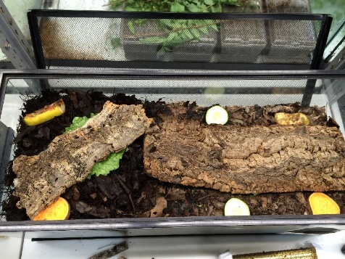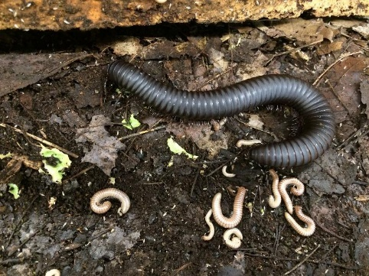

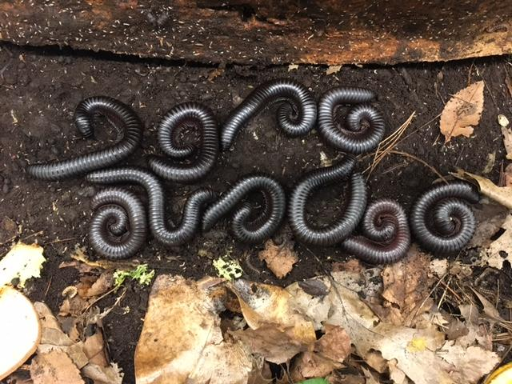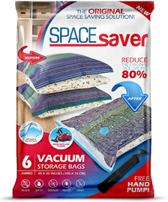

*Compost: All compost used for husbandry has been collected from the outdoor compost pile (which horticulture collects from zoo grounds) and placed in a large vacuum-sealed bag for 5 days. When the compost is added to the bags, all sticks are removed by hand first in order to keep the bag intact when the air is vacuumed out. Currently the bags are being stored in the room that excess the fire stick display in the back vestibule. The air is vacuumed out of the bags at least twice during the 5 day period. This allows the compost to keep its nutritional value as well as rid it of all potential pests/predatory species.

APPENDIX IV. Guidelines for Care and Maintenance – page 10 of 19

Giant Tropical Cockroach (Blaberus giganteus)
Animal Husbandry SOP, World of the Insect, Cincinnati Zoo & Botanical Garden
Daily Care: Add tetramin and Mazuri Roach Diet as needed. Thoroughly mist the exhibit and wipe down the glass with a paper towel to clean it.

- Sunday: Remove old veggies from both the public area and keeper area habitats. The public area habitat should get two - ¼ slices of apple dipped in tetramin, ½ slice of banana with Mazuri Roach Diet on top, and half of an ear of corn. The keeper area habitat should be fed four – ¼ slices of apple with tetramin, a banana sliced in two halves with Mazuri Roach diet on top of each, and a half of an ear of corn. The keeper area habitat should have a small dish of tetramin as well.
- Monday:
- Tuesday:
- Wednesday: Remove old veggies from both the public area and keeper area habitats. The public area habitat should get two - ¼ slices of apple dipped in tetramin, ½ slice of banana with Mazuri Roach Diet on top, and half of an ear of corn. The keeper area habitat should be fed four – ¼ slices of apple with tetramin, a banana sliced in two halves with Mazuri Roach diet on top of each, and a half of an ear of corn. The keeper area habitat should have a small dish of tetramin as well..
- Thursday:
- Friday: Remove old veggies from both the public area and keeper area habitats. The public area habitat should get two - ¼ slices of apple dipped in tetramin, ½ slice of banana with Mazuri Roach Diet on top, and half of an ear of corn. The keeper area habitat should be fed four – ¼ slices of apple with tetramin, a banana sliced in two halves with Mazuri Roach diet on top of each, and a half of an ear of corn. The keeper area habitat should have a small dish of tetramin as well.
- Saturday:

Quarterly Care: Once every three months the keeper area habitat will need to be cleaned and more compost* added if needed. The walls of the habitat should be wiped down with water and a paper towel.

6 Month Care: The keeper area habitat needs to be completely stripped out and cleaned. Remove all of the adults and nymphs from the habitat and place them into a 10 gallon tank with paper towels in them. Remove all substrate and place it in a 4 gallon, square bucket and date it with masking tape, three days from the current date. This bucket will be placed in the freezer for the next 72 hours at -20 degrees Fahrenheit. The four (or more) large pieces of cork bark should be scrubbed with water and

APPENDIX IV. Guidelines for Care and Maintenance – page 11 of 19

Giant Tropical Cockroach (Blaberus giganteus) - Continued
Animal Husbandry SOP, World of the Insect, Cincinnati Zoo & Botanical Garden

rinsed. The enclosure should be scrubbed with soap and water then dried with paper towels. Add three inches of compost to the bottom of the habitat. Next, add the pieces of cork bark back into the
habitat as vertically as possible and finally add the adults and nymphs back to the habitat with fresh food.

*Compost: All compost used for husbandry has been collected from the outdoor compost pile (which horticulture collects from zoo grounds) and placed in a large vacuum-sealed bag for 5 days. When the compost is added to the bags, all sticks are removed by hand first in order to keep the bag intact when the air is vacuumed out. Currently the bags are being stored in the room that excess the fire stick display in the back vestibule. The air is vacuumed out of the bags at least twice during the 5 day period. This allows the compost to keep its nutritional value as well as rid it of all potential pests/predatory species.

APPENDIX IV. Guidelines for Care and Maintenance – page 12 of 19
Indian Ornamental Tarantula (Poecilotheria regalis)
Animal Husbandry SOP, World of the Insect, Cincinnati Zoo & Botanical Garden

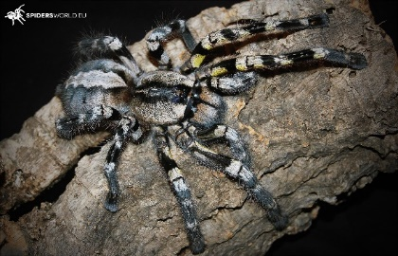

General Care: Dead or eaten crickets should be removed from the exhibit daily with forceps. Adult crickets are added every other week. Check feed card for the last ‘feed’ date. This species will eat up to 2 crickets at once. Glass is cleaned daily with a wet paper towel. All white tarantula waste should be removed if seen. If needed, use forceps to wipe down glass of any waste material or water spots. THIS IS AN EXTREMELY FAST SPECIES! If the crickets are not eaten right away, display tank should be removed and taken to the keeper area for removal of any live prey. If this animal is not close to molting, it is acceptable to leave in live prey items. Check the next morning to ensure pretty items have been consumed. If they have not, remove them.

Weekly Care: Clean out water dish weekly with hot water. Change gravel if needed. See above for feeding instructions.

Monthly Care: The exhibit gets stripped out as needed. Clean all plastic plants with hot water and soap. Replace them as needed. Refill exhibit display with two full scoops of pine fines or cocopeat. If removing tarantula, keep them in the plastic moving container until exhibit display is cleaned, set back up, and ready to be returned to the exhibit. Since this animal is fast moving, it is more easily contained in a smaller container until it is ready to be back in its original enclosure.

Moving or transferring a live tarantula: This species is known for sitting on the side of the exhibit display tank. If this is the case, quickly place the open container over the animal and then gently walk them over the lid. Always have a second keeper present when working with this species.

Venomous Species Special Instructions: This species has a toxic venom and is considered dangerous to humans. Never handle this species and if removal of this animal is required, always have a second keeper present for back-up. If you are bitten, follow the Venomous Protocol Procedures. If bitten, see bite protocol below.

APPENDIX IV. Guidelines for Care and Maintenance – page 13 of 19
Indian Ornamental Tarantula (Poecilotheria regalis) - Continued
Animal Husbandry SOP, World of the Insect, Cincinnati Zoo & Botanical Garden

BITE PROTOCOL

- Secure the arthropod. If you cannot quickly and safely secure the arthropod request assistance from a co-worker.
- Immediately notify a co-worker that you have been bitten or stung, and by what species.
- Remove any jewelry from the affected hand/wrist.
- Sit down near the telephone.
- You or a co-worker are to call the Zoo’s Security Base @ ext. 2222 and inform the dispatcher of your name, that you were bitten or stung and by what species, your current location, and your current condition.
- The dispatcher will have someone trained in first-aid respond to your location.
- You or a co-worker are to call Winton Ray (Curator of Invertebrates & Aquatic Animals) @ ext. 8346, 513559-8346 (office) or 513-430-0881 (cell) and inform him that you were bitten or stung and by what species, your current location and your current condition. He will contact further CZBG staff as appropriate.
IMAGE: Examples of plastic containers for moving tarantulas. Size of the container may vary depending on the size of the animal.

APPENDIX IV. Guidelines for Care and Maintenance – page 14 of 19
Madagascar Hissing Cockroaches (Gromphadorhina portentosa)
Animal Husbandry SOP, World of the Insect, Cincinnati Zoo & Botanical Garden
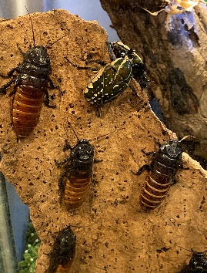
Daily Care: Add tetramin and Mazuri Roach Diet as needed. Wipe down the glass with a paper towel and RO water to clean it. Currently only males are displayed with the Magnificent Flower Beetles and the Diabolica mantids so care will have to be taken when switching out food.

- Sunday: Remove old veggies from both the public area and keeper area habitats. The public area habitat should get one - ¼ slice of apple dipped in tetramin, one chunk of sweet potato, ½ slice of banana with Mazuri Roach Diet on top, and half of an ear of corn. The keeper area habitat should be fed two - ¼ slices of apple with tetramin, two - ½ slices of banana with Mazuri Roach diet on top, and one chunk of sweet potato, half of an ear of corn. The keeper area habitat should have a small dish of tetramin as well. The perimeter of the keeper area habitat opening should be lightly oiled using 3-In-1 multi-purpose oil.
- Monday:
- Tuesday:
- Wednesday: Remove old veggies from both the public area and keeper area habitats. The public area habitat should get one - ¼ slice of apple dipped in tetramin, one chunk of sweet potato, ½ slice of banana with Mazuri Roach Diet on top, and half of an ear of corn. The keeper area habitat should be fed two - ¼ slices of apple with tetramin, two - ½ slices of banana with Mazuri Roach diet on top, and one chunk of sweet potato, half of an ear of corn. The keeper area habitat should have a small dish of tetramin as well. The perimeter of the keeper area habitat opening should be lightly oiled using 3-In-1 multi-purpose oil.
- Thursday:
- Friday: Remove old veggies from both the public area and keeper area habitats. The public area habitat should get one - ¼ slice of apple dipped in tetramin, one chunk of sweet potato, ½ slice of banana with Mazuri Roach Diet on top, and half of an ear of corn. The keeper area habitat should be fed two - ¼ slices of apple with tetramin, two - ½ slices of banana with Mazuri Roach diet on top, and one chunk of sweet potato, half of an ear of corn. The keeper area habitat should have a small dish of tetramin as well. The perimeter of the keeper area habitat opening should be lightly oiled using 3-In-1 multi-purpose oil.
- Saturday:

Monthly Care: Every month and a half the public area habitat should be stripped out, while the keeper area habitat should be stripped out once a month.

APPENDIX IV. Guidelines for Care and Maintenance – page 15 of 19
Madagascar Hissing Cockroaches (Gromphadorhina portentosa) – Continued
Animal Husbandry SOP, World of the Insect, Cincinnati Zoo & Botanical Garden

Public Area Habitat: Remove all of the adult roaches, mantids, and magnificent flower beetles and place them in critter keepers. Props should be removed and sprayed down with water. The substrate will be removed and sorted through for magnificent flower beetle larvae (see more in the
Magnificent Flower Beetle husbandry SOP). The empty habitat should be scrubbed with RO water as well as paper towels and a dobie scrubber. Fresh compost* will be added to the habitat so that the bottom 3-4” is covered. The props can then be added back in and the entire habitat well misted. Add the animals and food back in.

Keeper Area Habitat (19.5”L x 19.5”W x 30”H): Remove all of the adults and nymphs from the habitat and place them into a 10 gallon tank with paper towels in them. Remove all substrate and place it in a 4 gallon, square bucket and dated with masking tape, three days from the current date. This bucket will be placed in the freezer for the next 72 hours at -20 degrees Fahrenheit. The pieces of wood and cork should be scrubbed with water and rinsed. The enclosure should be scrubbed with soap and water then dried with paper towels. The perimeter of the habitat opening should be lightly oiled using 3-In-1 multi-purpose oil. Finally, add about three inches of organic potting soil to the bottom of the habitat. Next, add the cork bark and wood back into the habitat along with the adults and nymphs.

*Compost: All compost used for husbandry has been collected from the outdoor compost pile (which horticulture collects from zoo grounds) and placed in a large vacuum-sealed bag for 5 days. When the compost is added to the bags, all sticks are removed by hand first in order to keep the bag intact when the air is vacuumed out. Currently the bags are being stored in the room that excess the fire stick display in the back vestibule. The air is vacuumed out of the bags at least twice during the 5 day period. This allows the compost to keep its nutritional value as well as rid it of all potential pests/predatory species.

APPENDIX IV. Guidelines for Care and Maintenance – page 16 of 19

Red-eyed Assassin Bug (Plarymeris laevicollis)
Animal Husbandry SOP, World of the Insect, Cincinnati Zoo & Botanical Garden
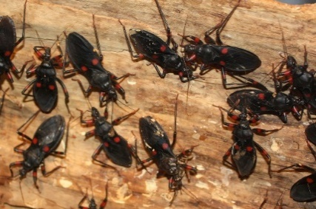
Daily Care: Dead or eaten crickets should be removed from the exhibit daily with forceps. New/live crickets are added daily. The amount of crickets depends on population and if live crickets remain from the previous day. Glass is cleaned daily with a wet paper towel. Remove any dead assassin adults. The keeper area tank is fed 3/8 inch crickets daily (amount depends on population). Add tetramin for excess crickets if needed to prevent predation on insects. Eggs for this species are laid in the substrate of the exhibit display.

Weekly Care: Keeper area rearing tank (10 gallon) is cleaned out weekly. Transfer all animals to fresh 10 gallon tank or thoroughly clean out the existing tank. Replace egg crate as needed (about every other week). Collect any adults and set up in the transfer container and place them on cart to be added to display during morning rounds the following day.

Monthly Care: The exhibit gets stripped out when hatchlings are observed, or every other month. Remove cork bark and any insects and place in a white bin (with the lid) in the clean room.

If saving hatchlings: Take exhibit substrate and place into a sweater box with holes drilled in the lid. Place ½ of an egg crate on top of the substrate. A post-it note gets added to the top of the sweater box and each hatchling removed is recorded on the post-it. Roughly 25-50 hatchlings are collected every other month, depending on how low the population of adults is at that time. Once you have collected enough hatchlings, freeze the substrate for three days before disposal. Back-up adults are housed in a 10-gallon tank in the keeper area. Rip apart 3 sheets of egg crate for hiding purposes. Substrate is not needed. Males are slightly larger than females. Females maybe seen with their abdomen buried in the dirt, laying eggs.

NOTE: If population of adults or nymphs remains high, saving eggs or hatchlings is not needed. Population of this species in the keeper area is reevaluated each time the exhibit is stripped. Too many adults may result in cannibalism, so refrain from keeping too many together in one exhibit or tank. Separating nymphs from adults is not needed, if enough food is provided. Keeping this species in one 10-gallon tank should suffice. If not, some individuals may need to be euthanized.

APPENDIX IV. Guidelines for Care and Maintenance – page 17 of 19

Red-eyed Assassin Bug (Plarymeris laevicollis) - Continued
Animal Husbandry SOP, World of the Insect, Cincinnati Zoo & Botanical Garden

Venomous Species Special Instructions: The Red-eyed assassin bug is a venomous species with a powerful bite. This species is always worked in tandem with the second person acting as a spotter to make sure bugs do not escape or cause harm to the person servicing them. 10-12inch forceps should be used to remove any dishes, crickets or materials from the enclosure. Only fully trained staff should be working with this species. Be aware that this species is capable of spraying venom from their moveable proboscis.

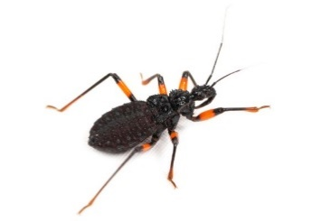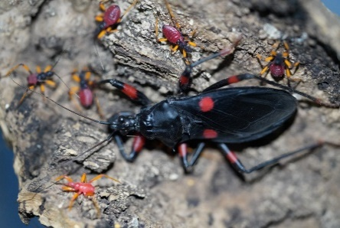
Nymph Adult surrounded by nymphs.

APPENDIX IV. Guidelines for Care and Maintenance – page 18 of 19

Red-knee Tarantula (Brachypelma smithi)
Animal Husbandry SOP, World of the Insect, Cincinnati Zoo & Botanical Garden

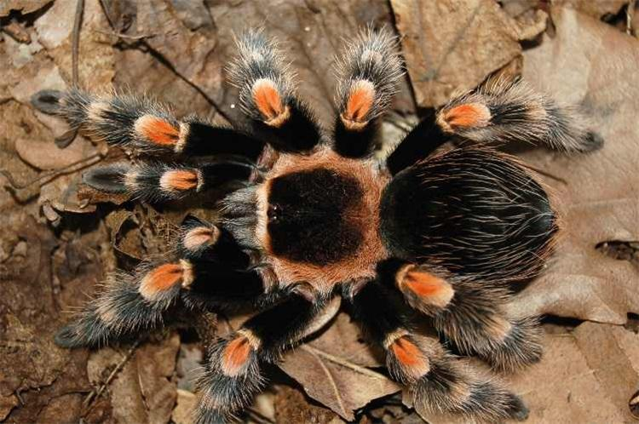

General Care: Dead or eaten crickets should be removed from the exhibit daily with forceps. Adult crickets are added every other week for the adult in the keeper area and once a week for the young individual on display. Check feed card for the last ‘feed’ date. If the crickets are not eaten right away, they should be removed. This species will eat up to 2 crickets at once. Glass is cleaned daily with a wet paper towel. All white tarantula waste should be removed if seen.

Weekly Care: Clean out water dish weekly with hot water. Change gravel if needed. See above for feeding instructions.

Monthly Care: The exhibit gets stripped out as needed. The tarantula can be removed and placed in a 10-gallon tank while cleaning their exhibit enclosure. Clean all plastic plants with hot water and soap. Replace them as needed. Refill exhibit display with two full scoops of pine fines or cocopeat mixed with sand (50/50 mixture).

Moving or transferring a live tarantula: Use the medium sized plastic container with the matching lid to move tarantulas (See image below). Do this by placing the lid on top of the soil. Then place the actual container over the tarantula and gently walk them over the lid. Use caution when sealing the lid to make sure legs are not trapped underneath.

Venomous Species Special Instructions: This species has a mild venom, but it is not considered dangerous to humans. Handling this tarantula is acceptable, if the animal remains calm. Do not hold this animal for more than 15 minutes at a time. This will help reduce stress. If bitten, see bite protocol below.

APPENDIX IV. Guidelines for Care and Maintenance – page 19 of 19

Red-knee Tarantula (Brachypelma smithi) - Continued
Animal Husbandry SOP, World of the Insect, Cincinnati Zoo & Botanical Garden

BITE PROTOCOL

- Secure the arthropod. If you cannot quickly and safely secure the arthropod request assistance from a co-worker.
- Immediately notify a co-worker that you have been bitten or stung, and by what species.
- Remove any jewelry from the affected hand/wrist.
- Sit down near the telephone.
- You or a co-worker are to call the Zoo’s Security Base @ ext. 2222 and inform the dispatcher of your name, that you were bitten or stung and by what species, your current location, and your current condition.
- The dispatcher will have someone trained in first-aid respond to your location.
- You or a co-worker are to call Winton Ray (Curator of Invertebrates & Aquatic Animals) @ ext. 8346, 513559-8346 (office) or 513-430-0881 (cell) and inform him that you were bitten or stung and by what species, your current location and your current condition. He will contact further CZBG staff as appropriate.

IMAGE: Examples of plastic containers for moving tarantulas. Size of the container may vary depending on the size of the animal.

