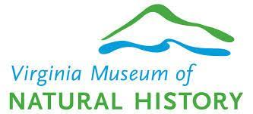
REPORT TO UNIVERSITY PARTNERS ad hoc COMMITTEE
May 2021
Joe Keiper, VMNH Director

The committee chose a direction to work individually with university partners, and to communicate with department chairs. Goal is to develop interest in using VMNH as a partner for community outreach efforts outlined in university grant proposals. The benefit to the university partner is VMNH’s experience in writing successful grant proposals, and expertise in delivering impactful programming. The benefit to VMNH is access to broader funding opportunities, such as developing outreach and / or exhibit solutions for NSF broader impact statements, though all granting agencies will be considered.

- A list of all research associates (RAs) has been circulated.

- Communication with RAs will provide to a core group of active researchers knowledge of the capacity of VMNH outreach strengths.

- RAs will be asked to pass information to department chairs for broader distribution.

- VISION:

- An informational package will provide general information on VMNH, including success stories.

- Success stories can include:

  - Descriptions of educational outreach.
  - Descriptions of science festivals.
  - Descriptions of exhibits developed in-house.
  - Traveling exhibit examples, including existing exhibits that can be modified to meet grant proposal needs.

- Informational package will provide an offer of partnership in grants that will be of mutual benefit to the university partner and VMNH.

- This can be followed up with a web page providing all the above information.

- Where possible, museum staff or board members can make pitches to university partners, such as at faculty meetings or seminars.

- TIMELINE:

- Staff will continue to assemble informational package.

- Distribution will be targeted for Fall 2021.

