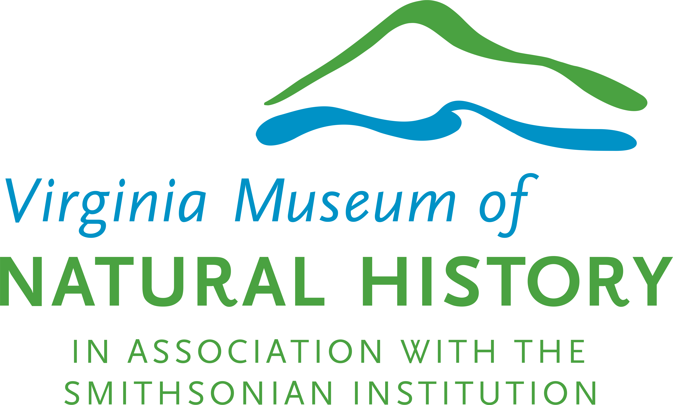

2023 Summer Adventure Camp - Scholarship Application

A limited number of scholarships are available for summer camps. Scholarships will be awarded on a need basis (must meet requirements on back). In an attempt to help as many children as possible, the Museum will provide registration for one (1) week of camp per accepted applicant. Please complete the camp registration form and return it with this application by the camp registration deadline. All information is confidential.

Return to: Virginia Museum of Natural History, attn: Summer Camp Scholarship, 21 Starling Avenue, Martinsville, VA 24112. A $25 deposit (cash or credit) is required and will be returned after your child has completed the camp. If your child does not attend, the deposit is non-refundable. Scholarship applications are due by the camp registration deadline.

Parent/Guardian Information
Parent/Guardian Name _______________________________________________________________
Address ___________________________________________________________________________
City, state, zip ______________________________________________________________________
Phone (home) ____________________ (cell) ____________________ (work) ___________________
Email ______________________________________________________________________________

Child’s Name | Age as of 6-1-23 | Camp Title

Financial Information

Household size __________

Must meet the Federal Eligibility Guidelines on the back of this application to qualify.
Do you qualify? Yes □ No □

Are there any financial circumstances you would like considered for this scholarship? Please explain:

To the best of my knowledge the above information is correct.

_____________________________________________ _______________________________
Parent/Guardian signature Date
